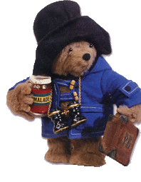
ABBEY HOME MEDIA PRESENTS…
PADDINGTON BEAR
- Available for the First Time on DVD -

Released under Abbey’s ‘Tempo TV Classics’ range - an adorable collection of children’s titles from the Film Fair catalogue, featuring puppet based, clay, and 2D animation - Paddington Bear holds timeless appeal to generations both old and new.

Available for the first time on DVD with interactive extras, this compilation of 12 episodes is taken from the original 1975 series, narrated by the late Michael Hordern.

Dressed in his characteristic duffel coat and oversized hat, loveable Paddington Bear has been capturing the imagination of children for decades. Based on the internationally acclaimed books by Michael Bond, Paddington remains one of the most successful children’s programmes ever produced in the UK.

DVD EXTRAS:

Paddington’s Puzzlers
– an 8 question interactive quiz to test your knowledge of everyone’s favourite bear.

Meet Paddington & Pals
- a biography of 3 characters from the series.

Product Details
Title: Paddington Bear – Please Look After This Bear
Release Date: 6th February 2006
Cat Number: AHEDVD3154
Barcode: 5012106931541
Cert: U

Runtime: 60 mins
RRP: £7.99

