ABBEY HOME MEDIA PRESENTS…
MOSCHOPS
Set in pre-historic times, this adorable series stars an energetic young dinosaur called Moschops.

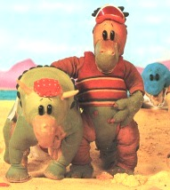
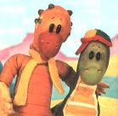
Don’t miss seeing this uber-cool, baseball-capped dino and his friends, Ally (an allosaurus), Uncle Rex (a tyrannosaurus), Mrs Kerry (a triceratops), big Grandfather Diplodocus and Mr Icthyosaurus (a welsh water-saurus who dwells in the nearby lake).

Actor Bernard Cribbins excels himself in voicing the characters, which are complemented by the character design. Teamed together with a fantastically catchy theme tune this DVD is a roaring success.

This compilation contains the first 5 episodes
- The First Flower
- All’s Well that Ends Well
- Nightmare Sun
- Fiercest Dinosaurs
- Tidiest Dinosaur

Product Details

Title: Moschops – The First Flower
Release Date: 13TH March 2006

Cat Number: AHEDVD3155
Barcode: 5012106931558

Cert: U
Runtime: 55 mins
RRP: £7.99

